**Financial Options**

**Call & Put Options**

# Option Contracts

# European Call Options

# Comparing Long and Short Positions

|  |  |
| --- | --- |
| **Long Position** | **Short Position** |
| Non-Negative Payoffs  NO Default Risk | Non-Positive Payoffs  Default Risk present |
| No Margin Required | Margin Required  No need for Covered Positions |
| Higher Upsides  Lower Downside  Seemingly better | Lower Upsides  Upside Downside  Seemingly worse |
| Low probability of exercise  Lose often but occasionally win big | High probability of NO exercise Win often but occasionally lose big |

# European Put Call Parity

## Put Call Parity for Comparison

* Due to the no arbitrage nature of PCP, it is commonly used to determine the relative values of Options or related assets
* Although it is common sense to read an inequality, it can be stressful to interpret inequalities under exam settings
* Thus, there is an easy method to read them:







$$

\begin{align*}

p_0 – c_0 &= Ke^{-rt} – F_0^P \\

p_0 &= c_0 + Ke^{-rt} – F_0^P

\end{align*}

 $$

Based on the sign of the additional terms, we replace the equal sign with an inequality,

|  |  |
| --- | --- |
| **Additional Terms are Positive** | **Additional Terms are Negative** |
|  |  |

 SKIP

# Synthetic Positions

* Note that put call parity uses a **Cashflow Perspective** at time 0:
  + **Negative Cashflow** → Cash outflow → Buy
  + **Positive Cashflow** → Cash Inflow → Sell
* By **re-arranging the equations** to match the **initial cashflow** of any position on the LHS, the RHS will produce the initial cashflow of **any replicating portfolio**

**Common Synthetic Positions**

Symthetic Position 
Long 
-co = -po + Ke 
Put 
-po — —co - + 
Kerr —po + co — Fop 
Treasury 
FOP SO 
Non-Dividend Stock 
—SO ¯ 
Dividend Stock 
Continuous Dividend 
—So 
CO - + PO 
— so - PV(D) 
+ PO + PV(D) 
Soe¯rq 
—So — Ke-rt + PO) 
Short 
co = po — Ke-rt + FOP 
¯ ¯ FOP 
Kerr = po — co + FOP 
so-co + Ke-rt —po 
FOP —so — PV(D) 
so + —po + PV(D) 
FOP Soe—rq 
so erq(co + Re-rt — PO) 

 SKIP

# Multiple Put Call Parity

* If you are given Option prices at different dates but with the **SAME MATURITY**, then PCP can be used to solve for the risk free rate

$$

\begin{align*}

p_{0, T} – c_{o, T} &= Ke^{-rT} – S_0 \\

p_{t, T} – c_{t, T} &= Ke^{-r(T-t)} – S_t

\end{align*}

$$





$$

e^{rt} = \frac{Ke^{-rT}}{Ke^{-r(T-t)}} = \frac{ p_{0, T} – c_{o, T} + S_0 }{ p_{t, T} – c_{t, T} + S_t}

$$



**Early Exercise of American Options**

# Early Exercise Condition

* The option will be exercised early **if it is more valuable to do so**
* There are two main benefits of each option:
  + Receiving Dividends
  + Investing the Strike
* Thus, we compare the PV of the above two values to decide if it should be exercised

$\text{PV Dividends} > \text{PV Interest} \rightarrow \text{Own the stock}$

$\text{PV Interest} > \text{PV Dividends} \rightarrow \text{Invest the money}$

* + 
  + 

|  |  |  |
| --- | --- | --- |
|  | **Exercise Early** | **Exercise Later** |
| **Long Calls** | Buy the stock now  Own the Stock  **Receive Dividends** | Buy the stock later  Save K  **Invest the amount** |
| **Long Puts** | Sell the Stock now    **Invest the amount** | Sell the stock later  Own the Stock  **Receive Dividends** |

 SKIP

## PV of Interest

Assume we invest $K$ for $t$ years at the risk free rate $r$,



$$

\begin{align*}

\text{Interest Earned } &= Ke^{rt} – K \\

\text{PV Interest } &= (Ke^{rt} - K)e^{-rt} \\

\therefore \text{PV Interest } &= K(1 – e^{-rt}

\end{align*}

$$







## PV of Dividends

Consider the formula for the Prepaid Forward,

$$

\begin{align*}

F_0^P &= S_0 - \text{PV}\(\text{Divs}\) \\

\text{PV}\(\text{Divs}\) = S_0 – F_0^P \\

\text{PV}\(\text{Divs}\) = S_0 \(1 – e^{-qt}\)

\end{align*}

$$







* Thus, by substituting the correct formula for the Prepaid Forward based on Discrete/Continuous Dividends, we can obtain the PV of dividends

## PV of Insurance

* Apart from receiving dividends and investing, another consideration is price movements of the asset
  + **Calls** → Risk of **price falling** immediately after exercising
  + **Puts** → Risk of **price rising** immediately after exercising (Opportunity Cost)
* These risks are present even if we exercise later; but we can minimize these risks **between the period of early exercise and maturity**
* We can value the protection by using options:
  + Protection against price falls → Put Options
  + Protection against price rises → Call Options
  + Note that the Insurance is always an **European Option**

|  |  |  |
| --- | --- | --- |
|  | **Exercise Early** | **Exercise Later** |
| **Long Calls** | Buy the stock now  **Risk of price fall** | Buy the stock later  **No risk of price fall** |
| **Long Puts** | Sell the Stock now  **Risk of price rise** | Sell the Stock Later  **No risk of price rise** |

## Proper Early Exercise Condition

* If one side is higher than the other, then we perform the action on that column

|  |  |  |
| --- | --- | --- |
|  | **Exercise Early** | **Exercise Later** |
| **Long Calls** | **Receive Dividends** | **Interest on Strike**  **Implicit Put** |
| **Long Puts** | **Interest on Strike** | **Receive Dividends Implicit Call** |

# Timing of Exercise

* Dividends are recognised as a **loss of capital** from the company thus the price of the stock will **fall by an amount equal to the dividend**
  + Call Payoffs are **directly proportional** to stock prices thus **should not experience** this price drop
  + Put Payoffs are **inversely proportional** to stock prices thus **should experience** the price drop
* Thus, if the option was going to be exercised early,
  + **Calls should be exercised right BEFORE** dividends are paid
  + **Puts should be exercise right AFTER** receiving dividends

# Non-Dividend Assets

* Based on the Early Exercise Condition, **higher dividends** increase the likelihood of early exercise of **Calls** and decreases the likelihood of **early exercise of Puts**
* For an asset with no dividends,
  + American Calls will **NEVER** be exercised early
  + American Puts **SHOULD (Not Guaranteed)** be exercised early
* Thus, an American Call whose underlying does not pay dividends is **identical to an European Call**
  + This application can be extended to cases where the underlying pays a **small dividend** - once it is confirmed that the option will not be exercised early, we can treat it as a European one

**Option Price properties**

# Lower Price Bounds

## Non-Negative Payoffs

* Option Holders will ONLY exercise the option for a positive payoff
* Conversely, Option Writers will ALWAYS have a negative payoff
* To compensate the Option Writer for bearing this risk, they will always charge a positive premium

$c_0 > 0$

$p_0 > 0$





## European No Arbitrage

* European Options MUST abide by **Put Call Parity** to avoid Arbitrage

$$

\begin{align*}

c_0 &= S_0 - Ke^{-rt} + p_0 \\

\therefore c_0 &\geq S_0 – Ke^{-rt}

\end{align*}

$$









## American No Arbitrage

* American Options are NOT bound by the Put Call Parity
* Since they can be exercised at any point in time, the cost of the option cannot be lesser than the immediate exercise value (**Cannot buy & sell immediately for profit**)

 $C_0 \geq S_0 - K$

$P_0 \geq K – S_0$





## Putting it all together

* Combining the above two conditions, we can express the lower bound in the form of a maximum function
* Notice that the lower price bounds are **identical to payoff graphs for an option\**

$c_0 \geq \max\(S-0 \ - \ Ke^{-rt}, \ 0\)$

$p_0 \geq \max\(Ke^{-rt} \ - \ S_0, \ 0\)$

$C_0 \geq \max\(S_0 \ - \ K, \ 0\)$

$P_0 \geq \max\(K \ - \ S_0 , \ 0\)$









# Upper Price Bounds

## European Best Case Scenario

* Upper price bounds are determined by considering the **Best Case Scenarios & Replicating Portfolios**
* We cannot use the Law of One Price to determine the lower limit - but we can apply a similar logic
* It **does NOT make sense** to pay a higher price for a lottery (Option) compared to the price for a guaranteed Best Case Scenario Replicating Portfolio

$\text{Best Call Payoff} \rightarrow S_T \rightarrow \text{Preparid Forward} \rightarrow F_0^P = S_0$

$\therefore S_0 \leq c_0$

$\text{Best Put Payoff} \rightarrow K \rightarrow \text{Zero Coupon Bond} \rightarrow Ke^{-rt}$

$\therefore Ke^{-rt} \leq p_0$









## American Best Case Scenario

* Since American Options can be exercised early, we consider the Immediate Exercise Value instead
* We would NOT pay to enter a contract with a lower maximum payoff than the cost to enter it

$\text{Best Call Payoff} \rightarrow S_0$

$\therefore S_0 \leq C_0$





$\text{Best Put Payoff} \rightarrow K$

$\therefore K \leq P_0$





## Putting it all together

* Notice that the lower price bounds are **identical to payoff graphs for a Stock or Bond**

$S_0 \leq c_0$

$Ke^{-rt} \leq p_0$





$S_0 \leq C_0$

$K \leq P_0$





## European VS American Options

* American Options can do everything that a European Option can
* American Options have the **added flexibility** of being exercised early which can result in better payoffs
* Thus, American Options must be priced at least as much as European Options

$C_0 \geq c_0$

$P_0 \geq p_0$





# Combining Upper & Lower Bounds

$S_0 \geq c_0 \geq \max\(S_0 \ - \ Ke^{-rt}, \ 0\)$

$Ke^{-rt} \geq p_0 \geq \max\(Ke^{-rt} \ - \ F_0^P, \ 0\)$





$ S_0 \geq C_0 \geq \max\(S \ - \ K}, \ 0\)$

$ K \geq P_0 \geq \max\(K \ - \ S, \ 0\)$





|  |  |  |  |
| --- | --- | --- | --- |
|  | **Lower Bound** | **Upper Bound** | **Image** |
| **European Call** |  | Stock | II |
| **American Call** |  | Stock | I |
| **European Put** |  |  | IV |
| **American Put** |  |  | III |

SKIP

x—S-100 
95.12 

# 

# 

# Strike Price Condition

* 
* Based on the relative strike prices, we can form conclusions about the Option Prices **based on no arbitrage arguments**

## First Proposition: Option Prices and Strike Prices

* Call Payoffs are inversely related to the Strike Price
* Put Payoffs are directly related to the Strike Price
* Options with **higher payoffs must cost more** than an option with a lower payoff

$c\(K_1\) > c\(K_2\) > c\(K_3\)$

$p\(K_3\) > p\(K_2\) > p\(K_1\)$





## Second Proposition: Difference in Option Prices and Strike Prices

* All else equal, the difference in Payoff is the difference in Strike Prices
* The ***maximum* difference** in the price should be the difference in Payoff/Strike Prices
  + American Options can directly use the difference since they can be exercised immediately
  + **European** Options should use the **present value** of the difference

$C\(K_1\) – C\(K_2\) \leq K_2 – K_1$

$P\(K_2\) – P\(K_1\) \leq (K_2 – K_1$





$c\(K_1\) – c\(K_2\) \leq (K_2 – K_1)e^{-rt}$

$p\(K_2\) – p\(K_1\) \leq (K_2 – K_1)e^{-rt}$





## Third Proposition: Rate of Change in Option Prices

* **Call prices decreases slower** relative to the change in Strike Prices
  + **Gradient decreases** with respect to Strike Prices → Convex Curve
* **Put Prices increase faster** relative to the change in Strike Prices
  + **Gradient increases** with respect to Strike Prices → Concave Curve

$\text{Gradient}_1 \geq \text{Gradient}_2$

$\frac{C\(K_2\) - C\(K_1\)}{K_2 – K_1} \geq \frac{ C\(K_2\) - C\(K_3\)}{K_3 – K_2}$





$\text{Gradient}_2 \geq \text{Gradient}_1$

$\frac{p\(K_3\) - p\(K_2\)}{K_3 – K_2} \geq \frac{ p\(K_2\) - p\(K_1\)}{K_2 – K_1}$





C(K2) 
C(K3) 
P(KJ) 
Ρ(Κ2) 

## Practical Application

* 
* Based on the strike price condition, **calls with lower strikes have higher premiums**
* 
  + Options kink upwards from left to right
  + Options move from upwards to reflect lower costs
* 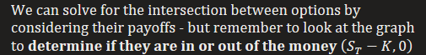
  + Rule of thumb is that for option diagrams to intersect, **one of the options has to be in the money and another out** (Otherwise they will be parallel and never intersect)

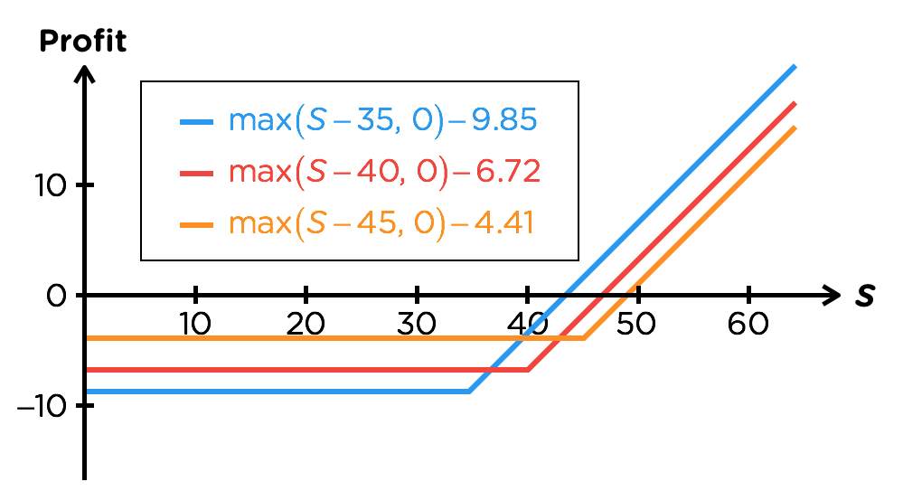



* Options kink upward from right to left
* Options move upward to reflect lower cost

# Time to expiration Condition

* 
* **American Options** with a **longer expiration can do everything** that one with a shorter expiration can and more, thus should cost more
* European Calls on a non-dividend paying assets are the same as American Calls, thus this property also applies to them as well
  + For European Calls on dividend paying assets and for all European Puts, this is ***generally true*** because a longer lasting contract should cost more
  + But there are **rare exceptions** that will violate it thus it is not a binding rule





For a non-dividend paying asset,

